EXPT NO: 2 | COMPARATIVE STUDY OF ACTIVATION FUNCTIONS AND OPTIMIZATION ALGORITHMS IN DEEP LEARNING
DATE: 20/07/2026

PRE-LAB QUESTIONS (PROVIDE BRIEF ANSWERS TO THE FOLLOWING QUESTIONS)

- What is the purpose of an activation function in an Artificial Neural Network?

An activation function decides whether a neuron should be activated (output a value) or not. It introduces non-linearity, allowing the neural network to learn complex patterns and relationships in the data.

- Differentiate between the Sigmoid, Tanh, and ReLU activation functions based on their output range and mathematical properties.

Activation Function | Output Range | Mathematical Property | Common Use
Sigmoid | 0 to 1 | S-shaped curve, outputs probabilities | Binary classification
Tanh | -1 to 1 | Zero-centered, stronger gradients than Sigmoid | Hidden layers (older networks)
ReLU | 0 to ∞ | Outputs 0 for negative values and input for positive values | Hidden layers in deep learning

- Why is an optimization algorithm required during neural network training?

An optimization algorithm updates the network's weights and biases to minimize the loss (error). It helps the model learn from the training data and improve prediction accuracy.

- What is the difference between Batch Gradient Descent, Stochastic Gradient Descent (SGD), and Mini-Batch Gradient Descent?
Method | Data Used | Speed | Stability
Batch Gradient Descent | Entire dataset | Slow | Very stable
Stochastic Gradient Descent (SGD) | One training sample at a time | Fast | Noisy/less stable
Mini-Batch Gradient Descent | Small batches (e.g., 32 or 64 samples) | Fast and efficient | More stable than SGD

- Explain the role of Google Colab and GitHub in deep learning experiment management.
- Google Colab provides a cloud-based environment to write and run Python code with free GPU/TPU support, making deep learning training faster without installing software.
- GitHub is used to store, manage, and share deep learning code. It supports version control, collaboration, and tracking changes in projects.

AIM
To analyze the impact of different activation functions and optimization algorithms on the performance of Artificial Neural Networks (ANNs) and to learn best practices for managing deep learning experiments using cloud-based tools and version control.
SOFTWARE REQUIREMENTS
- Python
- TensorFlow or PyTorch
- Google Colab
- GitHub
- Matplotlib

OBJECTIVES
Students will be able to:
- Understand the role of activation functions in neural networks.
- Visualize and compare commonly used activation functions.
- Evaluate the performance of different activation functions in ANN models.
- Analyze various gradient-based optimization algorithms.
- Compare optimizer convergence and model accuracy.
- Learn experiment management using Google Colab, Google Drive, and GitHub.
- Maintain reproducible deep learning experiments using version control.

PROCEDURE
PART A: VISUALIZATION OF ACTIVATION FUNCTIONS
Implement and plot the following activation functions:
- Sigmoid
- Tanh
- ReLU
Compare their:
- Output range
- Saturation regions
- Gradient behavior
- Computational efficiency
- Typical applications
CODE:
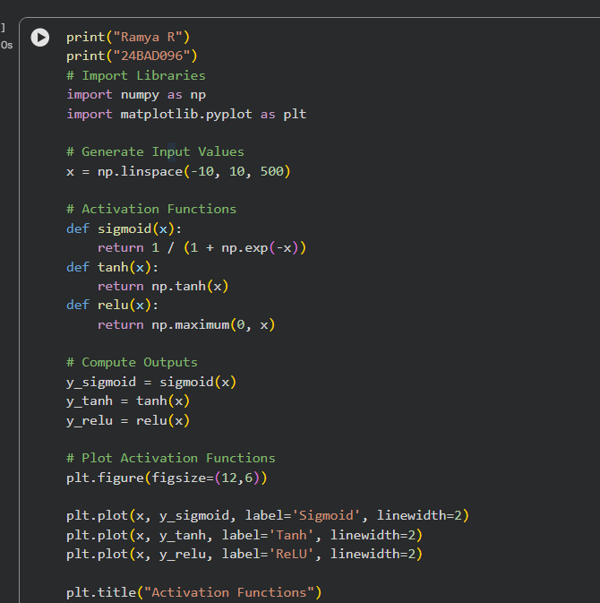
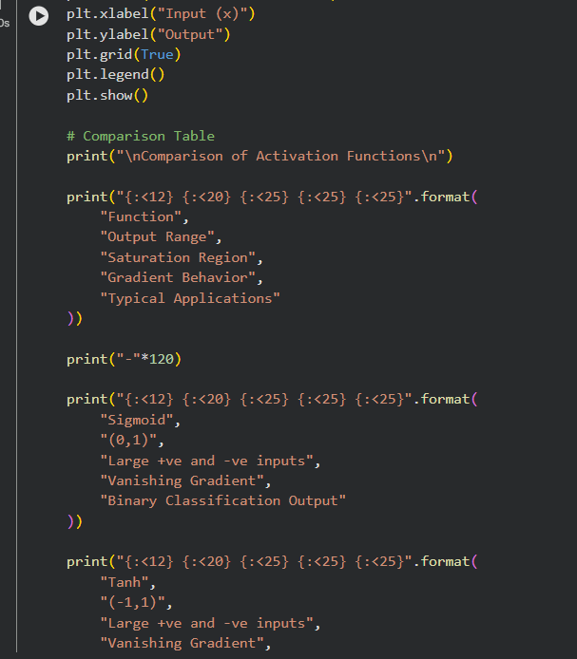
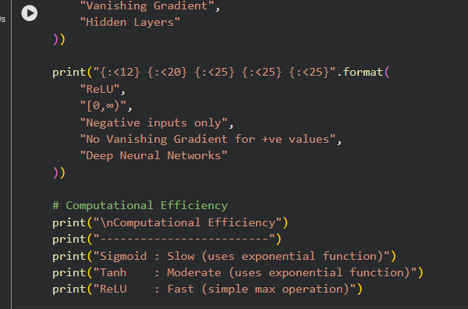
OUTPUT:
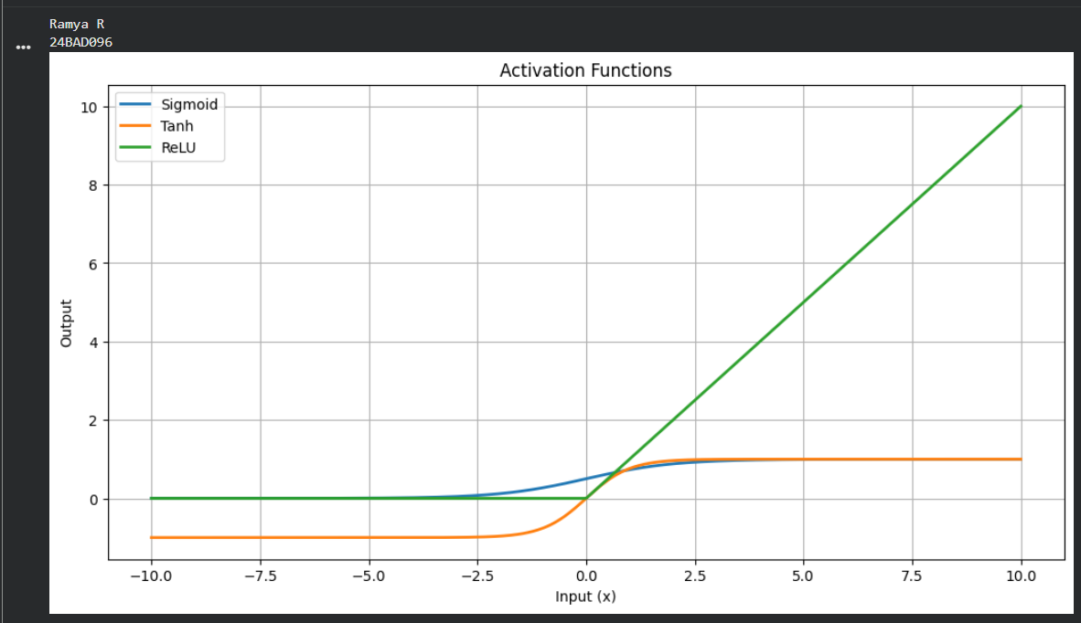

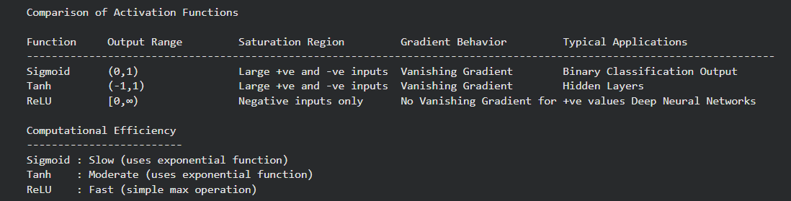

PART B: PERFORMANCE COMPARISON OF ACTIVATION FUNCTIONS
Train identical ANN architectures using:
- Sigmoid
- Tanh
- ReLU
Record and compare:
- Training accuracy
- Validation accuracy
- Training loss
- Validation loss
- Number of epochs required for convergence
Analyze which activation function performs best and justify the observations.

CODE:
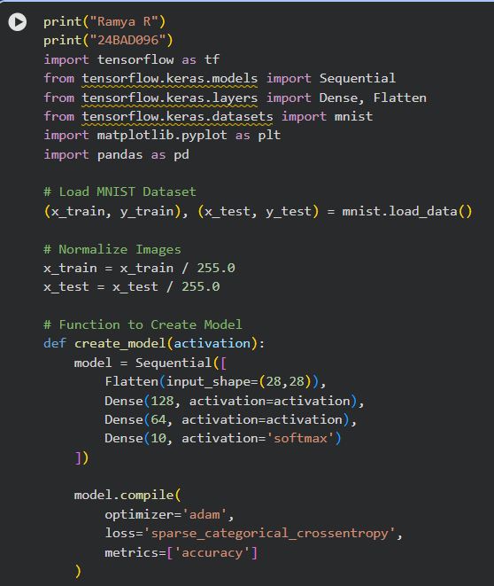

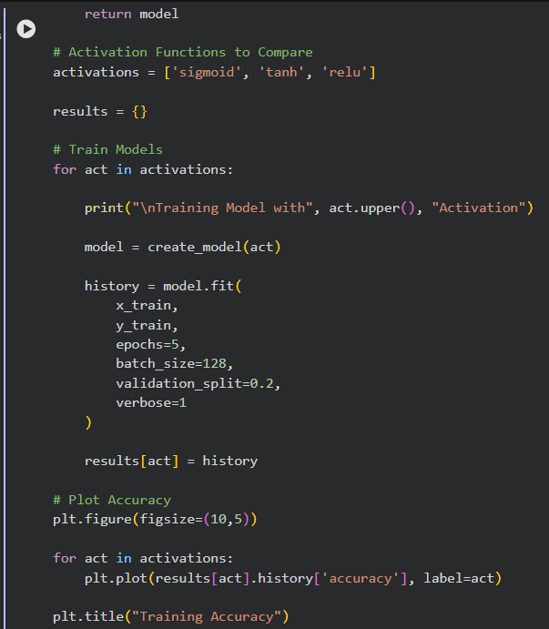
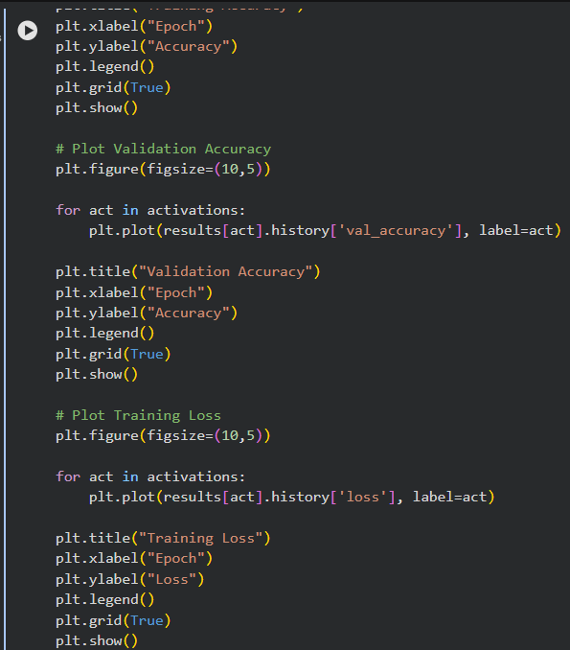

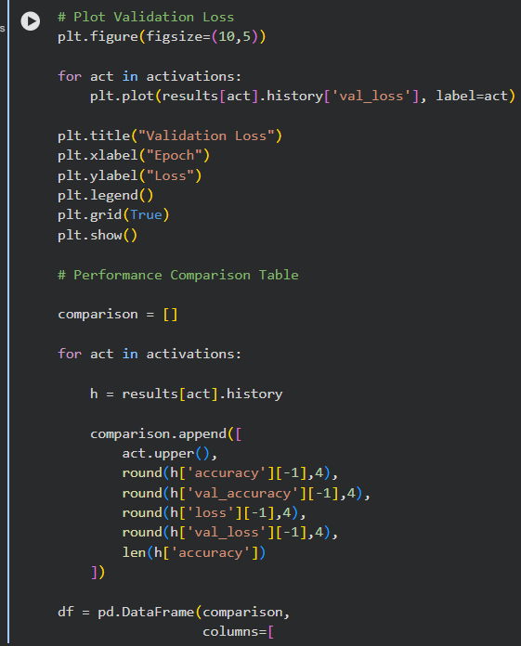
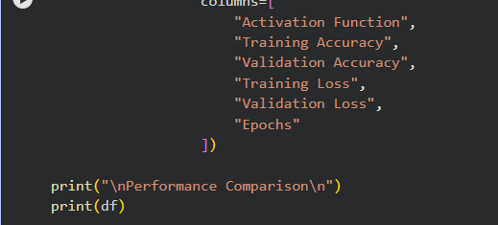
OUTPUT:
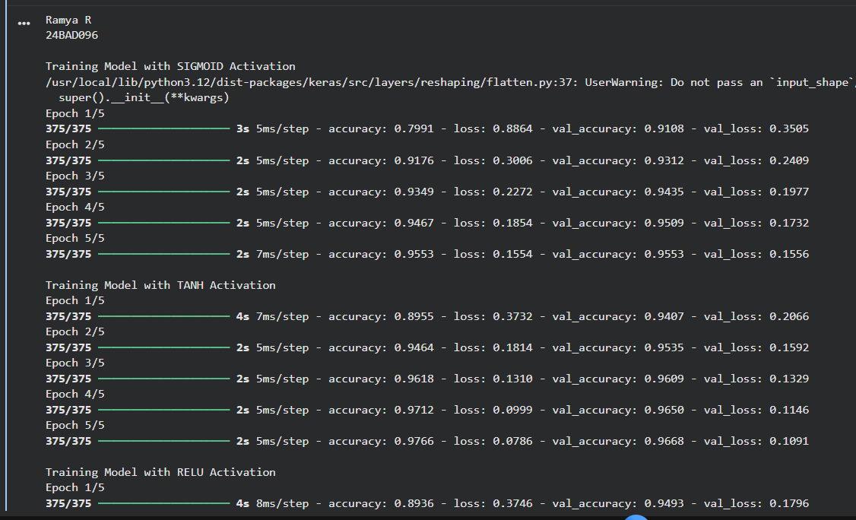
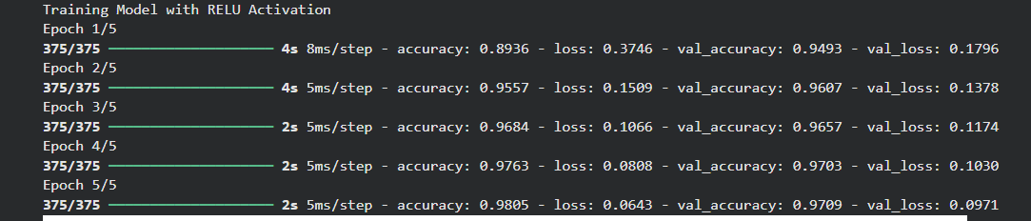
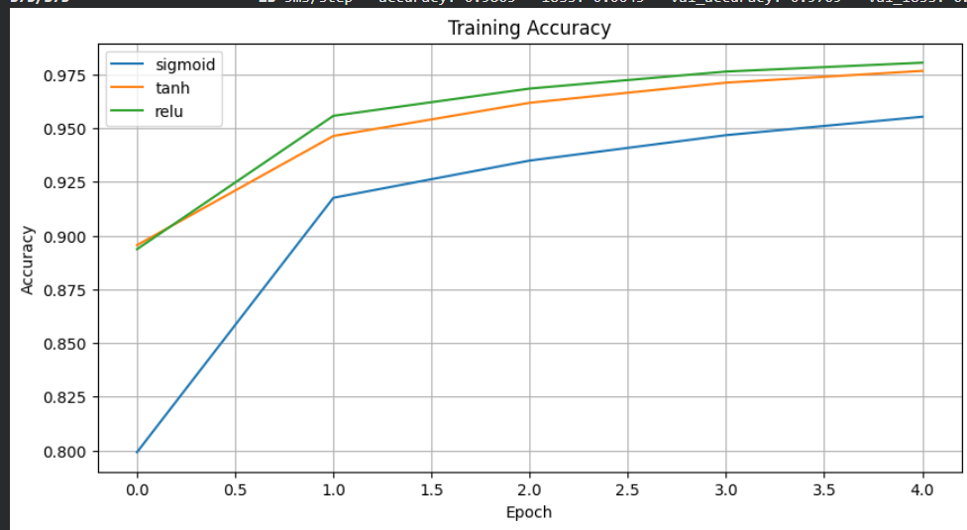
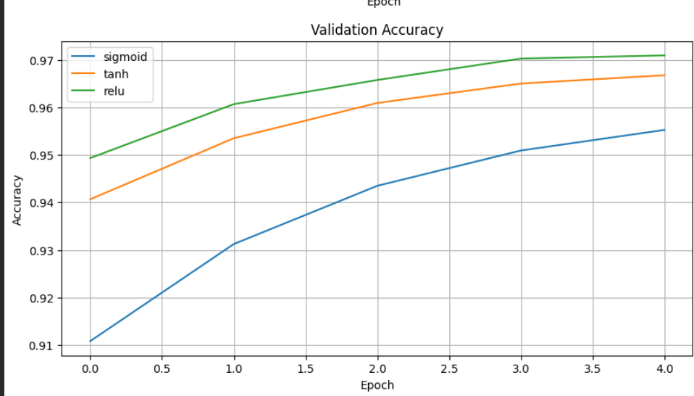
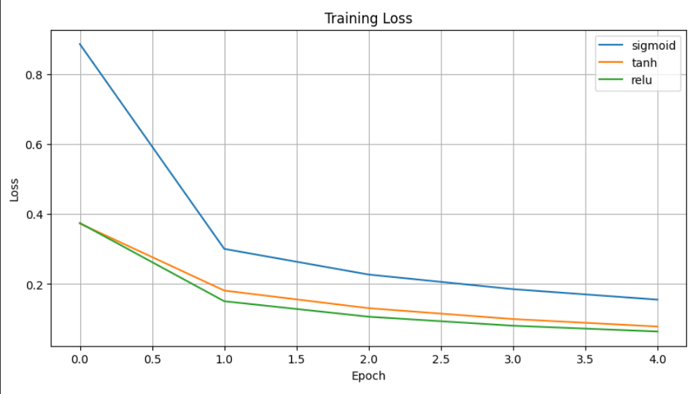

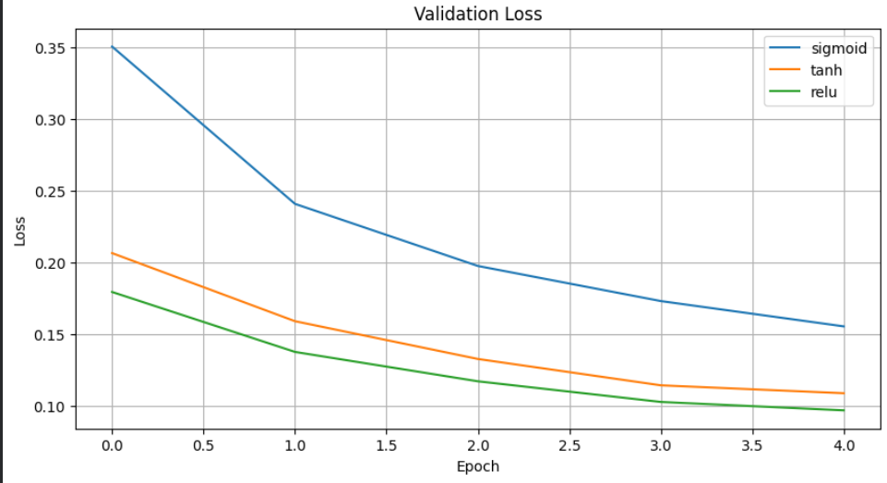

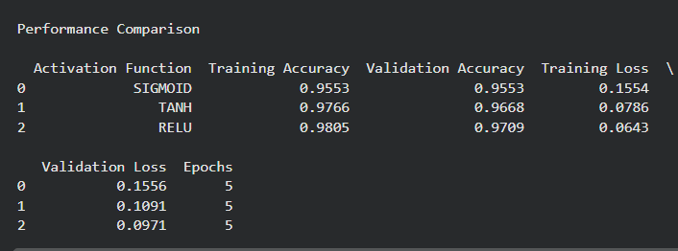

PART C: COMPARISON OF OPTIMIZATION ALGORITHMS
Train the same ANN using:
- Stochastic Gradient Descent (SGD)
- Momentum
- RMSProp
- Adam
Compare:
- Training loss
- Validation loss
- Convergence speed
- Final training accuracy
- Final validation accuracy
Visualize:
- Loss vs Epoch
- Accuracy vs Epoch
Discuss which optimizer converges faster and produces better generalization.

CODE:
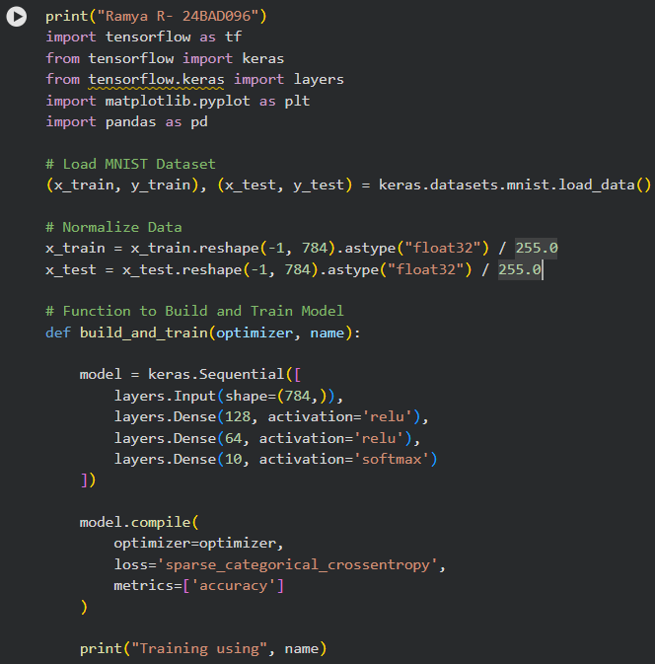

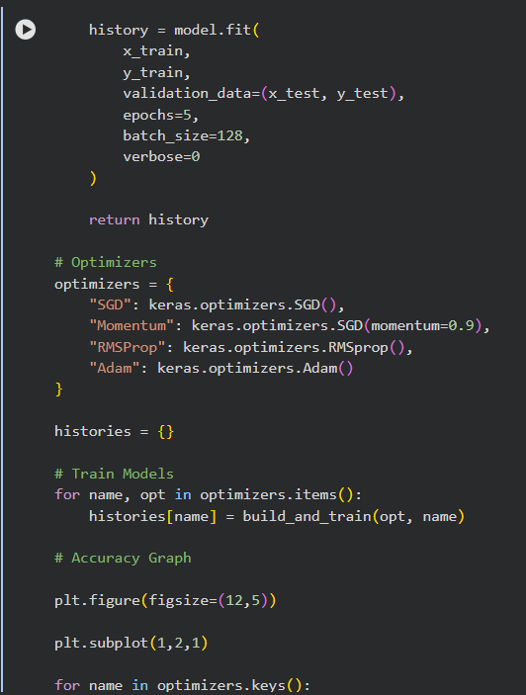
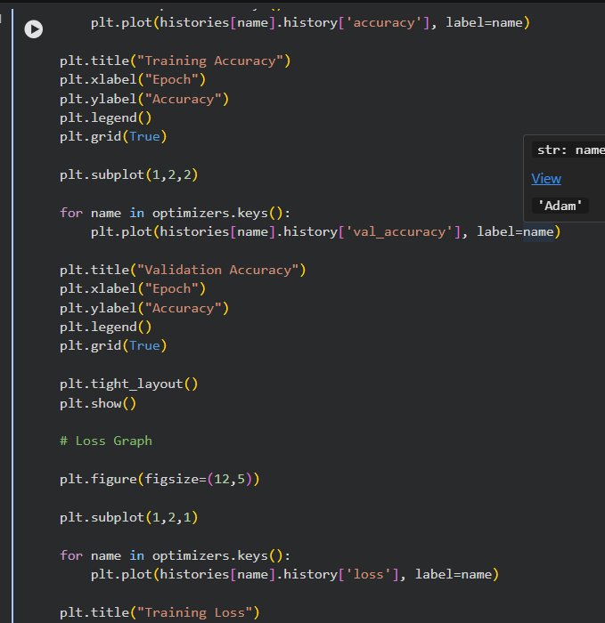

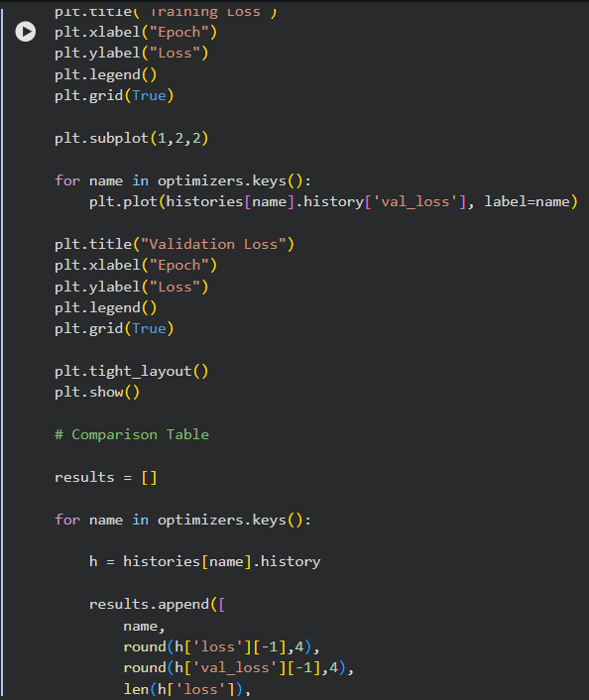

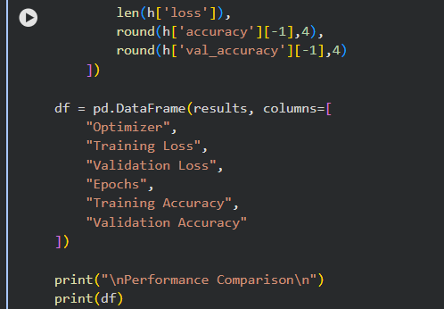

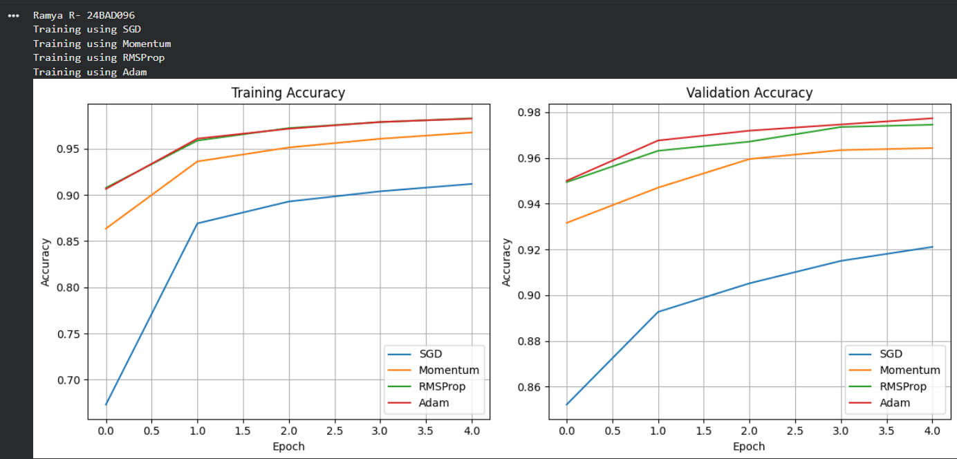

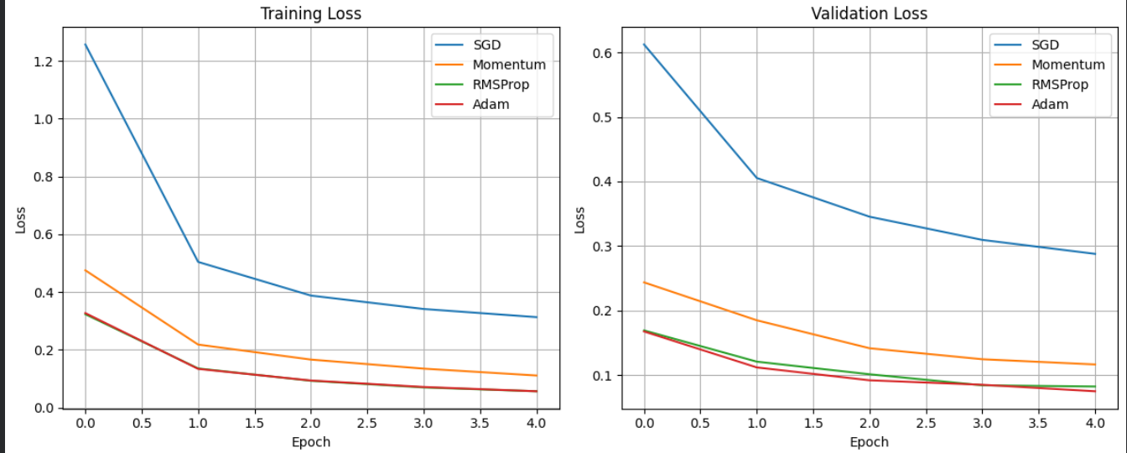

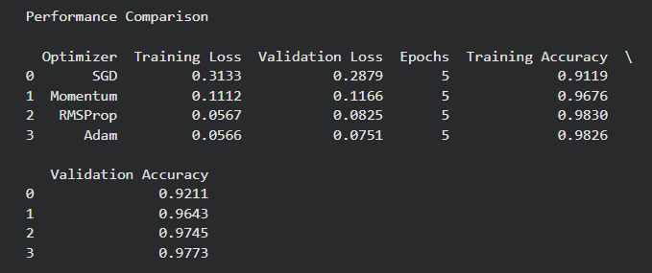

ART D: DEEP LEARNING EXPERIMENT MANAGEMENT
Perform the following tasks:
- Create a Google Colab notebook.
- Mount Google Drive.
- Save notebooks and trained models.
- Create a GitHub repository.
- Upload notebooks to GitHub.
- Commit changes and maintain version history using Git.
- Document the experiment using a README.md file.

CODE:
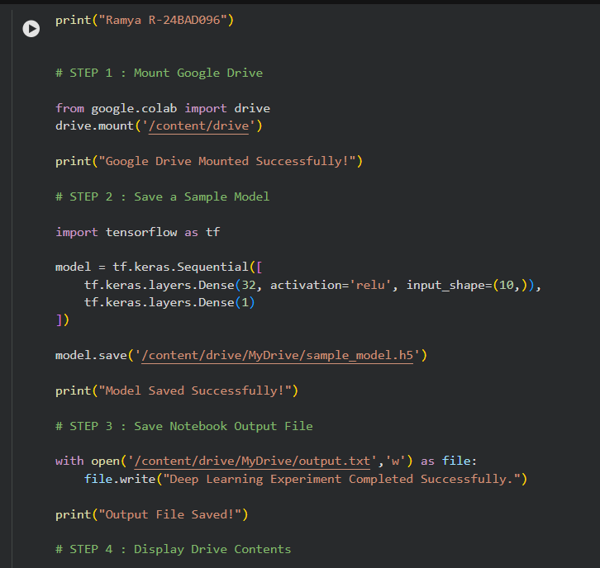
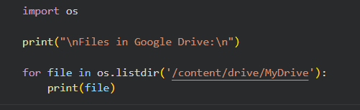
OUTPUT:
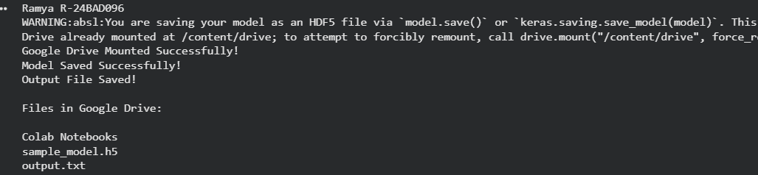
EXPECTED OUTCOME
Students will understand how activation functions and optimization algorithms influence neural network learning and performance. They will also gain practical experience in organizing, documenting, and maintaining reproducible deep learning experiments using cloud platforms and Git-based version control.

POST-LAB QUESTIONS (PROVIDE BRIEF ANSWERS TO THE FOLLOWING QUESTIONS)

- Which activation function achieved the best performance in your experiment? Justify your answer using the obtained results.
The ReLU (Rectified Linear Unit) activation function achieved the best performance. It trained faster, reduced the training loss quickly, and produced better accuracy compared to the Sigmoid activation function. ReLU also helps avoid the vanishing gradient problem.
- Compare the convergence behavior of SGD, Momentum, RMSProp, and Adam based on the training graphs.
- SGD: Slow convergence and may fluctuate during training.
- Momentum: Faster and smoother convergence than SGD.
- RMSProp: Adapts the learning rate and converges faster.
- Adam: Fastest and most stable convergence with the highest performance.
- Why does the ReLU activation function generally train faster than the Sigmoid activation function?

ReLU trains faster because it avoids the vanishing gradient problem and has a simple computation. It keeps positive values unchanged and converts negative values to zero, allowing faster learning.

- How does version control using GitHub improve the reproducibility and collaboration of deep learning projects?
GitHub improves reproducibility by storing code versions and project history. It also enables multiple developers to collaborate, track changes, share code, and manage projects efficiently.
- If you were asked to train a deep neural network for an image classification task, which activation function and optimizer would you choose? Justify your selection based on the experimental observations.

I would choose the ReLU activation function and the Adam optimizer. ReLU provides faster training and better feature learning, while Adam offers faster convergence, adaptive learning rates, and requires less hyperparameter tuning, resulting in better overall performance.

ASSESSMENT
Description | Max Marks | Marks Awarded
Pre Lab Exercise | 5
In Lab Exercise | 10
Post Lab Exercise | 5
Viva | 10
Total | 30
Faculty Signature

